Anderson EOY Sponsors: Additional Information
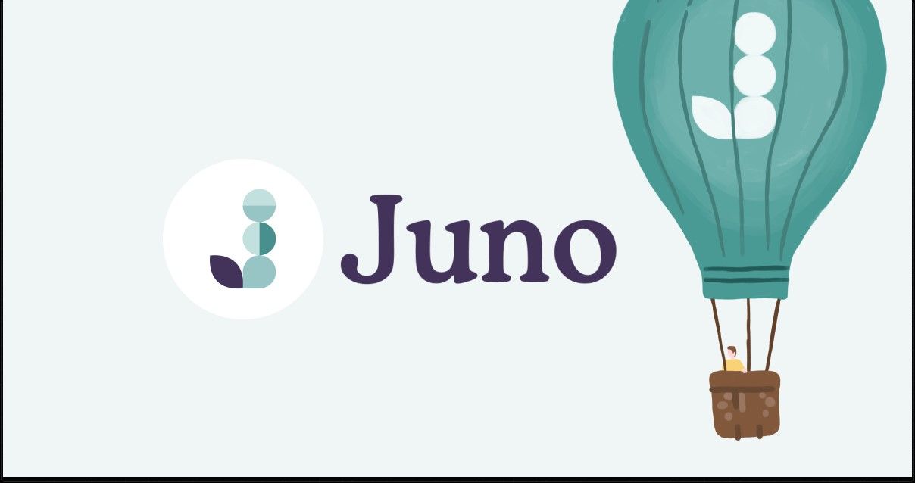
Do you need help paying for your MBA? Our partner Juno is a startup founded by two former MBAs that negotiate group discounts for MBA loans.

Here’s, how it works:
- From now until April 30th, MBA students join the group.
- In May, Juno gets final bids from banks and credit unions who want to serve the group. Then, they select the most competitive offers based on who provides the lowest rates.
- In June, they make those offers available to you.
Joining their negotiation group does not obligate you to take a loan (or to do anything). Think of it as a free option that gives you access to the lowest rates Juno can negotiate.

The latest negotiation group has 3,200+ MBA students, representing ~$200M+ in buying power. The larger the group, the more attractive it is to lenders, and the more willing they are to trade margin for volume
Use code CMBUCLA for a 1 month free premium subscription to Coffee Meets Bagel

The CMB way

We’re helping the daters who are ready for something serious and tired of wasting time on people who aren’t. Here’s how we’ll get you the relationship you’re looking for 👇

Curated community

We ask upfront what you want and deliver daily batches of people picked just for you, so you can match with confidence.

Detailed profiles

Do they want kids? Are your values aligned? The important details like education, interests, and family plans are front and center.

Chats made for meeting

We’ll help you get the conversation rolling with icebreakers, then help you move the conversation to real life with chat limits.

iOS: Use deeplink https://apps.apple.com/redeem?ctx=offercodes&id=630119301&code=CMBUCLA
Android: Register an account on CMB -> Look for the 1 month Premium subscription -> In the purchase flow, choose redeem code under payment options -> Use code CMBUCLA
T&Cs:
Expires 30 Sep'24
Available for new subscribers only
Offer is valid for attendees of the UCLA Anderson School of Management event in the USA.
Offer contains a free 1-month trial of Coffee Meets Bagel (CMB) Premium.
Offer auto-renews at the end of the free trial into a 1-month Premium subscription. Offer expires September 30th, 2024.
Offer is non-exchangeable for cash and non-transferable.
The code can be redeemed by both new users and existing users who have not had a prior subscription

